Computer Networks Practical File

Name:- Ankit Chawla Roll no:- 224050

Index

|  |  |
| --- | --- |
| 1 | To study basic network command and network configuration commands |
| 2 | To study and perform PC to PC communication using ethernet |
| 3 | To create Star topology using hub and switch |
| 4 | To create Bus, Ring, Tree, Hybrid, Mesh topologies |
| 5 | Perform an initial Switch configuration |
| 6 | Perform an initial Router configuration |
| 7 | To implement Client Server Network |
| 8 | To implement connection between devices using router |
| 9 | To perform remote desktop sharing within LAN connection(non packet tracer) |

Practical 1

Ip config

**ipconfig** is a command-line utility primarily utilized on Unix-like operating systems to manage and present details regarding network interfaces. It serves the purpose of viewing and adjusting network interface configurations, including IP addresses, netmasks, and interface statuses.

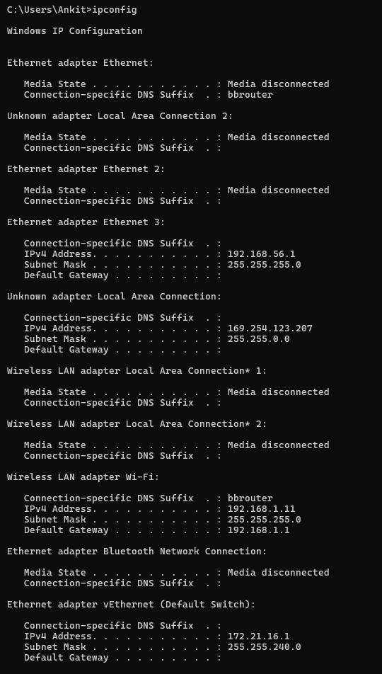

*nslookup*

(Name Server Lookup) is a command-line utility designed to request information from Domain Name System (DNS) servers, enabling the retrieval of domain names or IP addresses. It facilitates troubleshooting of DNS-related problems and allows manual execution of DNS queries.

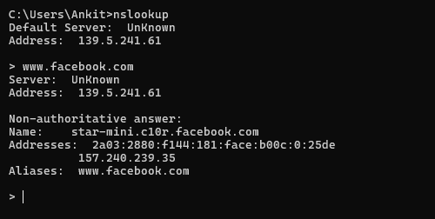

PING

A fundamental network tool utilized to assess the accessibility of a host on an Internet Protocol (IP) network. It dispatches ICMP Echo Request messages to the designated host and awaits ICMP Echo Reply messages in response.

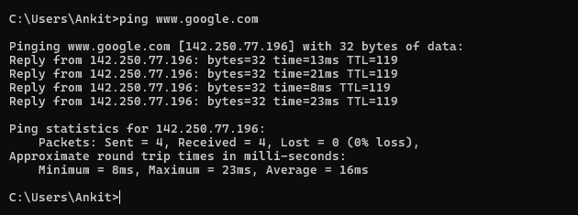

tracert

A network diagnostic utility that illustrates the path traversed by packets across an IP network. It reveals the IP addresses of the routers (hops) between the source and destination, along with the corresponding packet transit times for each hop.

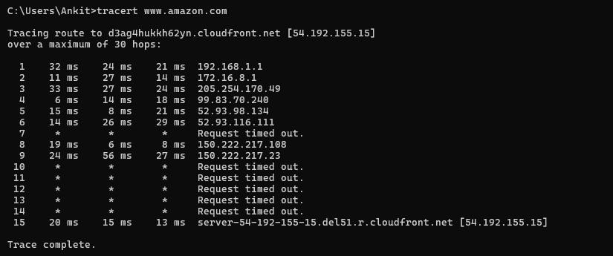

netstat

Netstat, short for Network Statistics, is a command-line utility that showcases various network-related details including active network connections, routing tables, interface statistics, masquerade connections, and multicast memberships. It offers insights into active network connections, listening ports, and other pertinent network information.

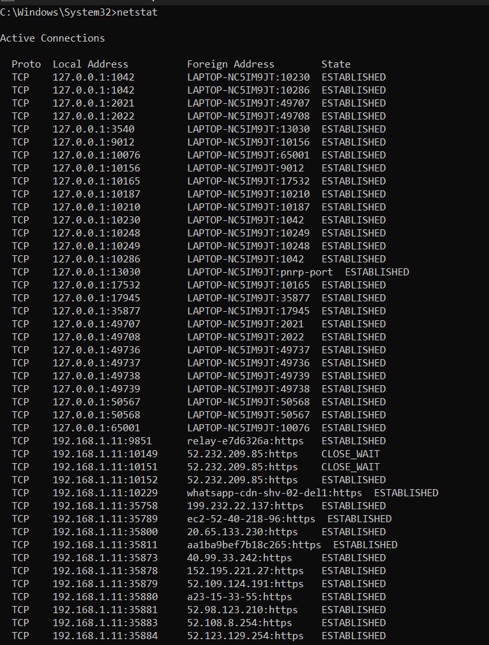

arp

The Address Resolution Protocol (ARP) is a network protocol utilized for associating an IP address with a physical machine address, also known as a MAC address, within a local network. The **arp** command enables users to view and manage the ARP cache, which holds mappings of IP addresses to MAC addresses.

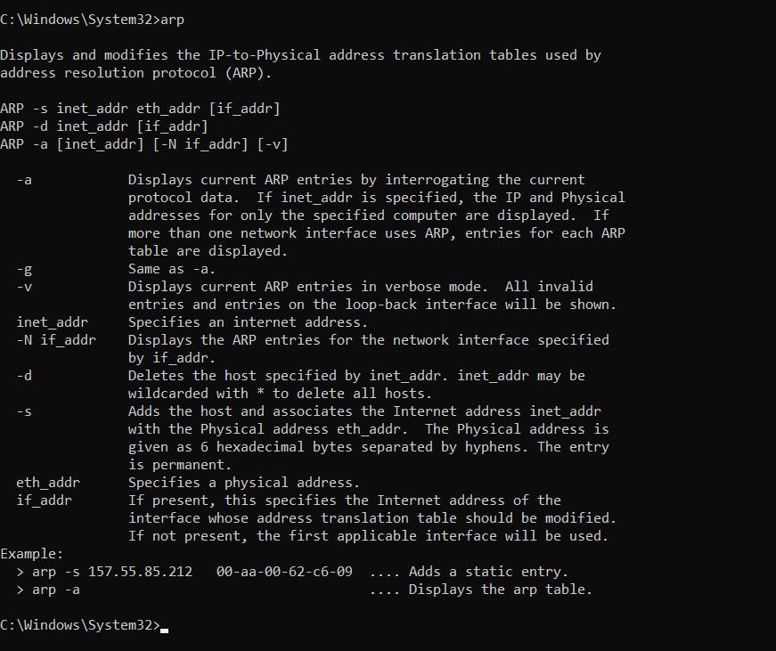

systeminfo

*Windows-specific command used to display detailed information about the system's hardware, software, and configuration.*

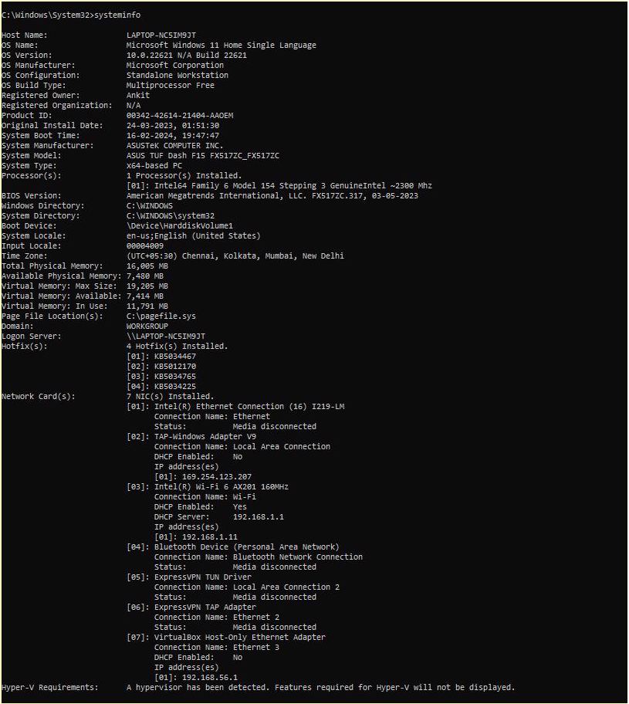

Pc to pc

Connection:-

1.In end devices selects 2 pcs

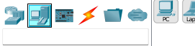

2.Then go to connection and select copper crossover cable and connect with Fast Ethernet port of pc1 to pc2

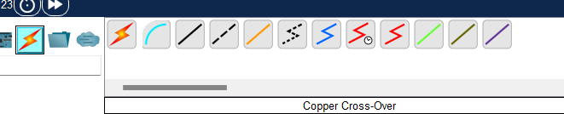

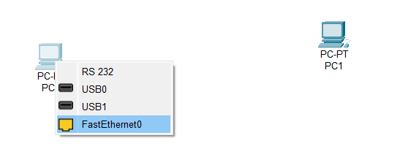

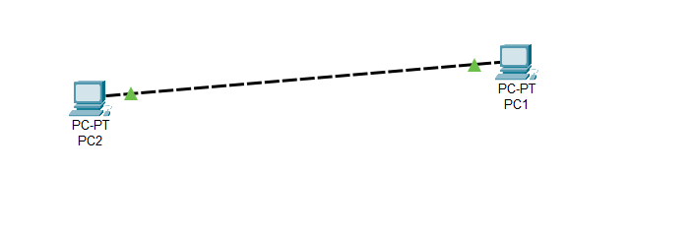

3.Assign the Ip addresses by clicking on pc then going to desktop and then ip config

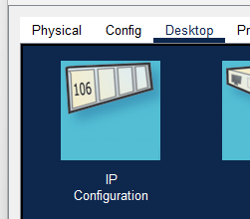

1st pc ip address:- 192.168.1.1

2nd pc ip address:- 192.168.1.2

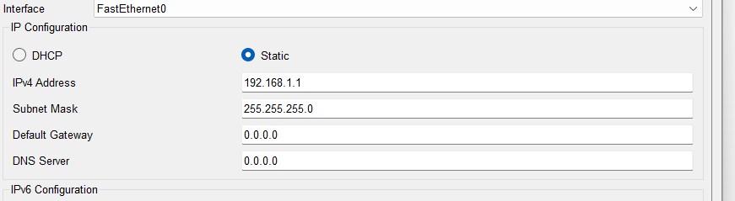

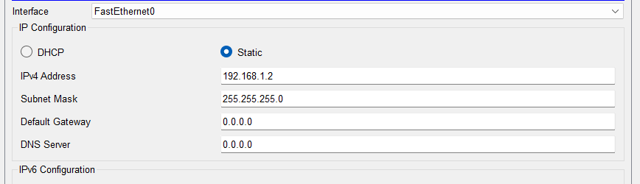

4. Now to check the connection on top left select the option with message icon(add simple pdu) and then click on pc 1 and then pc 2

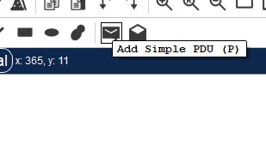

5. Now on bottom right you can see whether the message sent successfully from pc1 to pc2 or not not

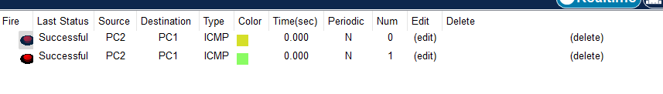

HUB to PC

Connection:-

1.In Hub tab from network devices select A Hub and Select desired no of PCs from the end devices

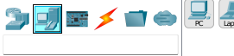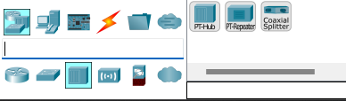

2.Connect all PCs and hub with copper straight cable by selecting it through the cables menu from the bottom left menus in the simulator. Green signal in the wire shows they’re ready to communicate.

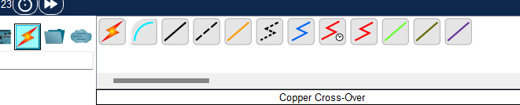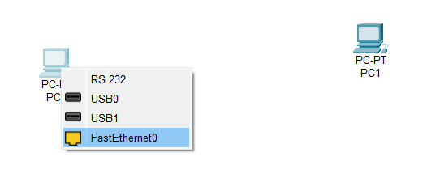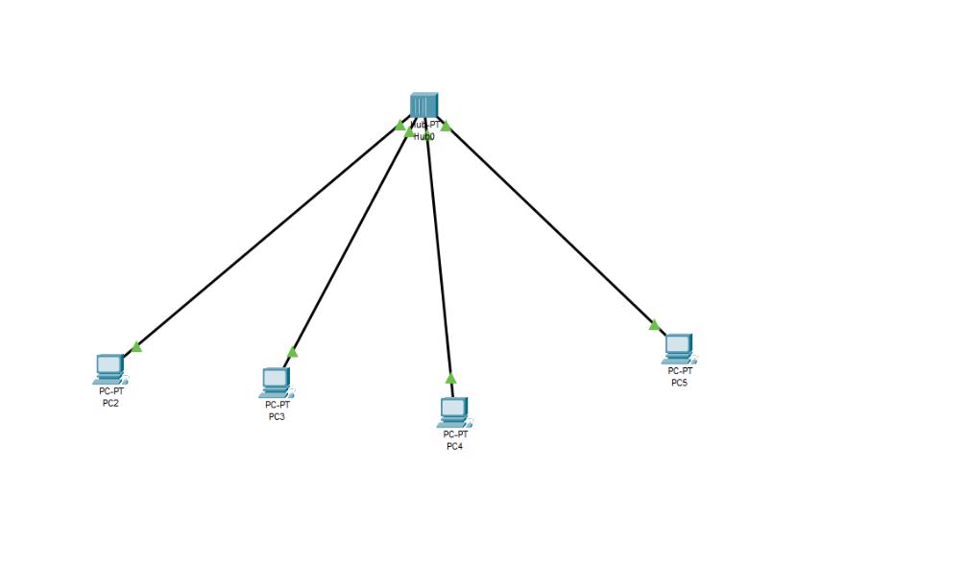

3.Assign Different IP addresses to all PCs by clicking on PC then going to desktop and then IP Configuration

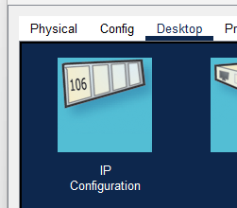

1st pc IP address:- 192.168.1.1 2nd pc IP address:- 192.168.1.2 3rd pc IP address:- 192.168.1.3 4th pc IP address:- 192.168.1.4

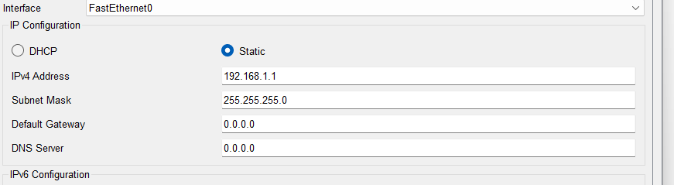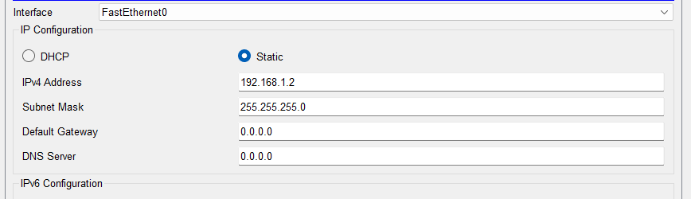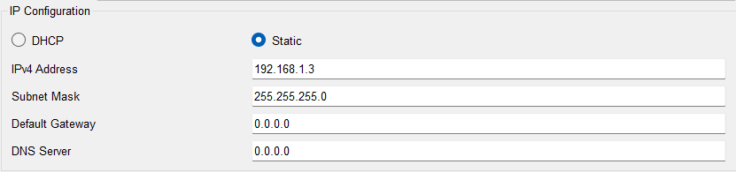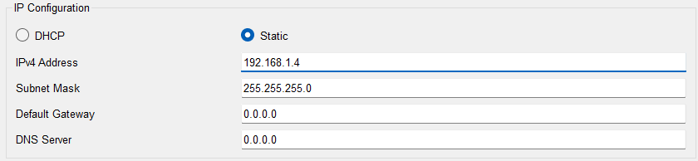

1. Click on a PC, go to Desktop and then click on Command prompt.
2. After that test the ping command in command prompt to check the connectivity between these PCs.

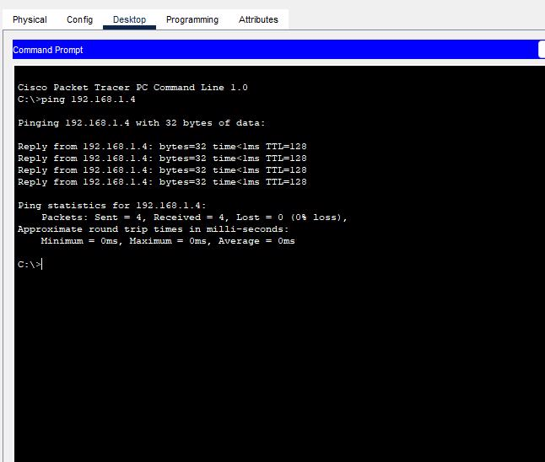

Step 1 : Take several PC’s and a switch

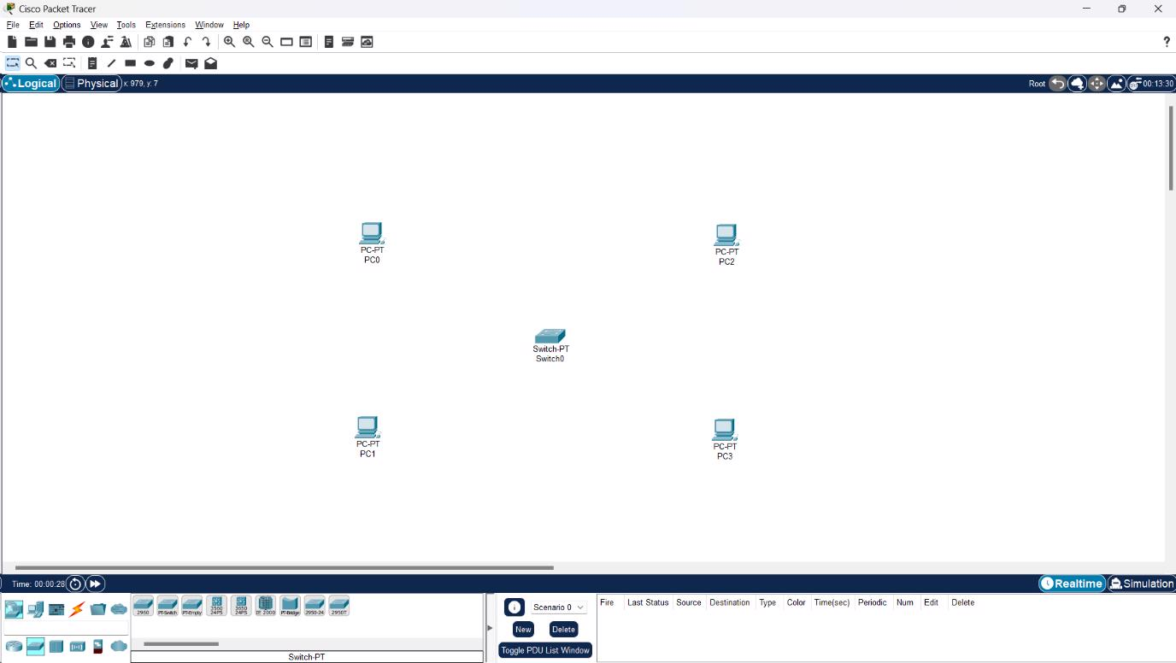

Step 2 : Link them

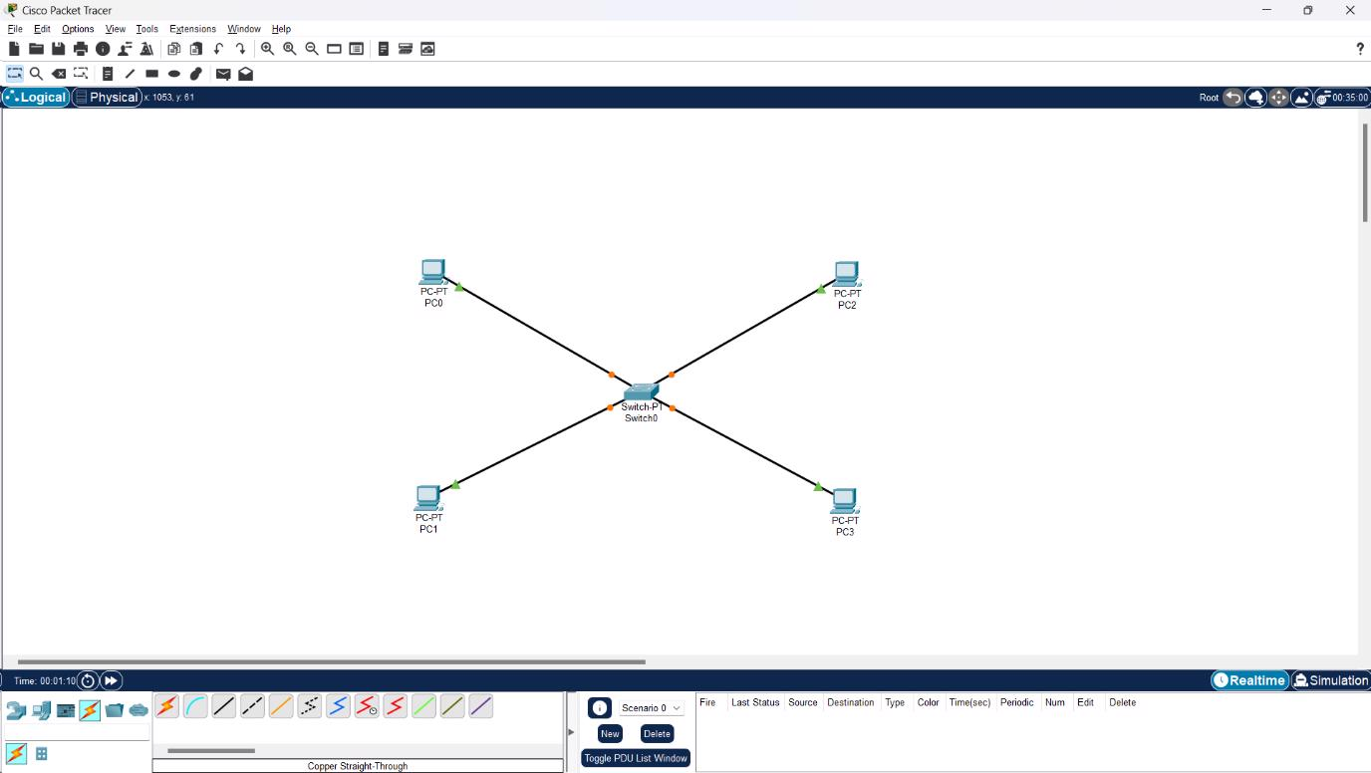

Step 3 : Provide IP address to each PC

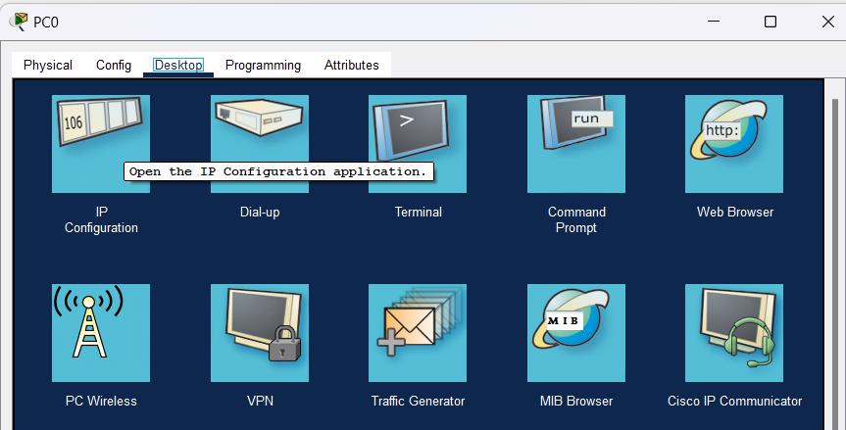

Step 5 : Transfer message from one device to another and check the status

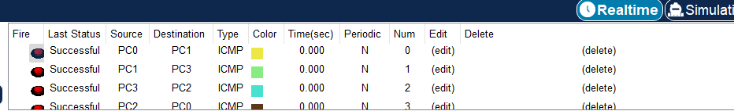

Step 6 : Run the ping command

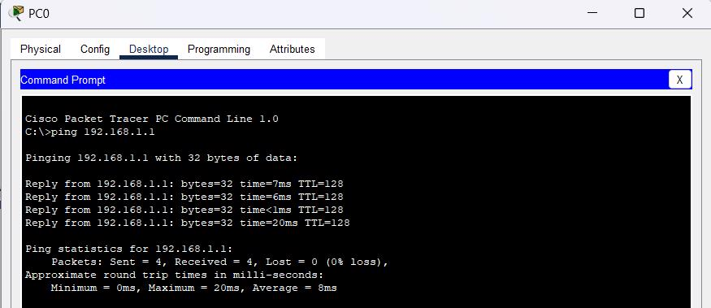

Bus topology

Step 1

Set up 4 pc and 4 switches in a grid

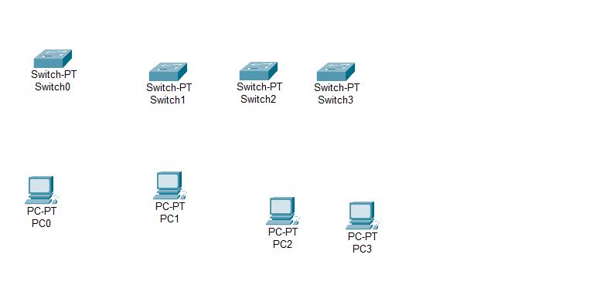

Step 2

connect each switch with 1 pc and connect all switches together in 1 line one after another

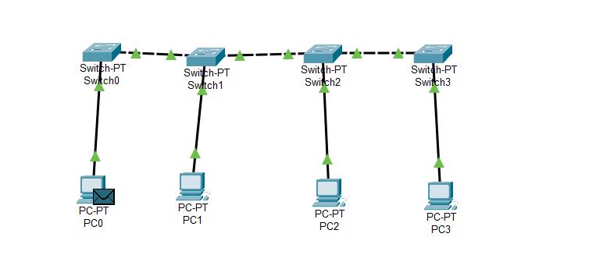

Step 3

Assign ip

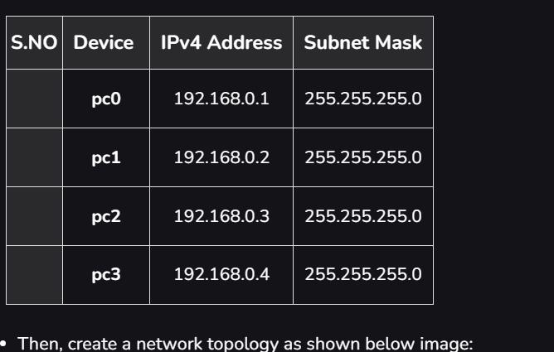

Step 4

Send a message to confirm the setup



RING TOPOLOGY

Step 1 : Select PC’s and Switches and connect them

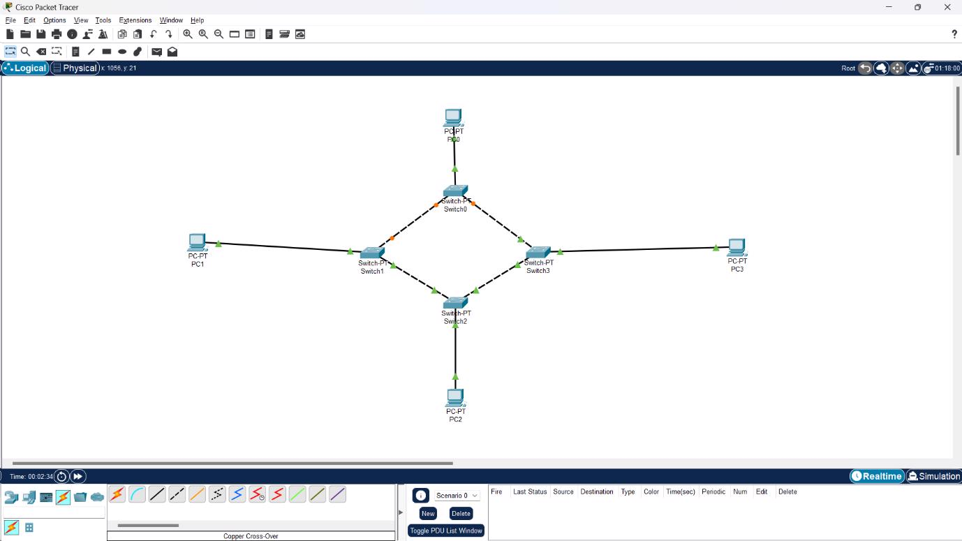

Step 2 : Assign IP address

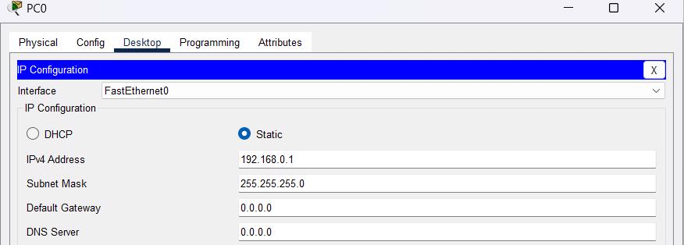

Step 3 : verify connection using ping command

Step 4 : Send two PDU packets one targeted from PC0 to PC2 and another targeted from PC2 to PC1.

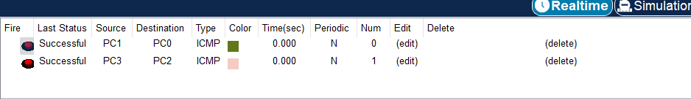

TREE TOPOLOGY

Step 1 : Select PC’s and Switches and connect them

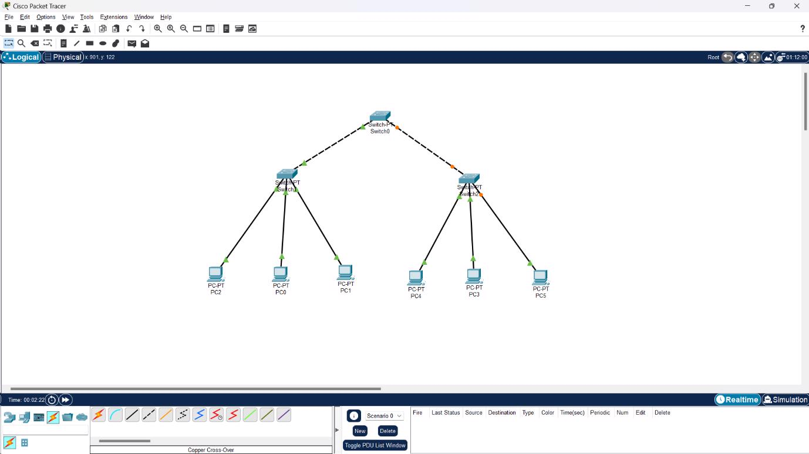

Step 2 : Assign IP address



Step 3 : verify connection using ping command

Step 4 : Send PDU packets one targeted from PC0 to PC3 and another targeted from PC2 to PC4.

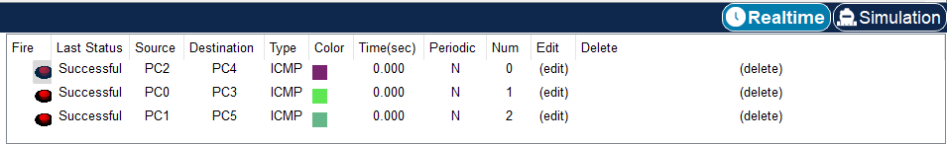

MESH TOPOLOGY

Step 1 : Select PC’s and Switches and connect them

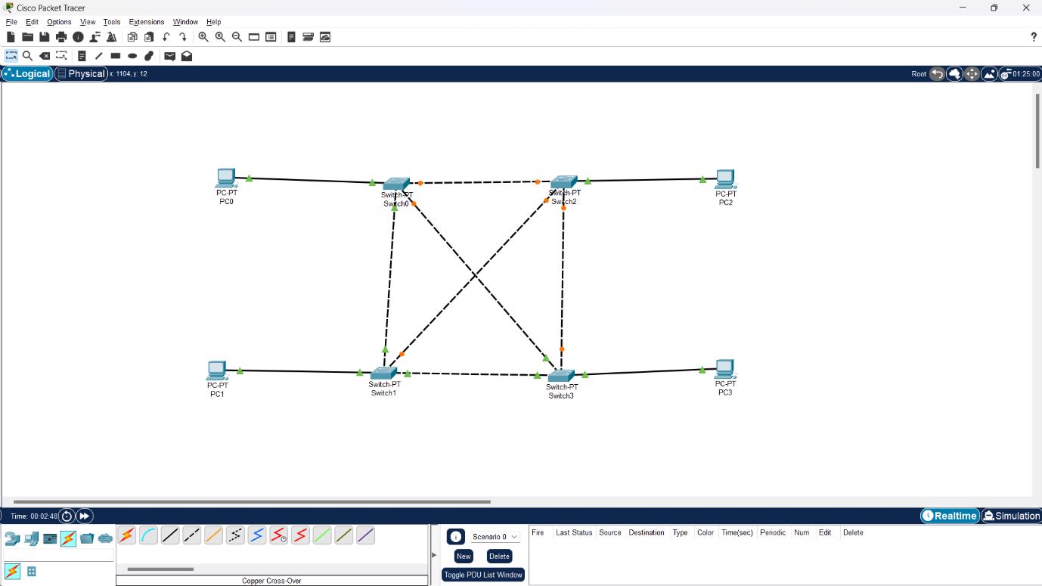

Step 2 : Assign IP address



Step 3 : verify connection using ping command

Step 4 : Send PDU packets one targeted from PC0 to PC3 and another targeted from PC1 to PC2.



HYBRID TOPOLOGY

Step 1 : Select PC’s and Switches and connect them

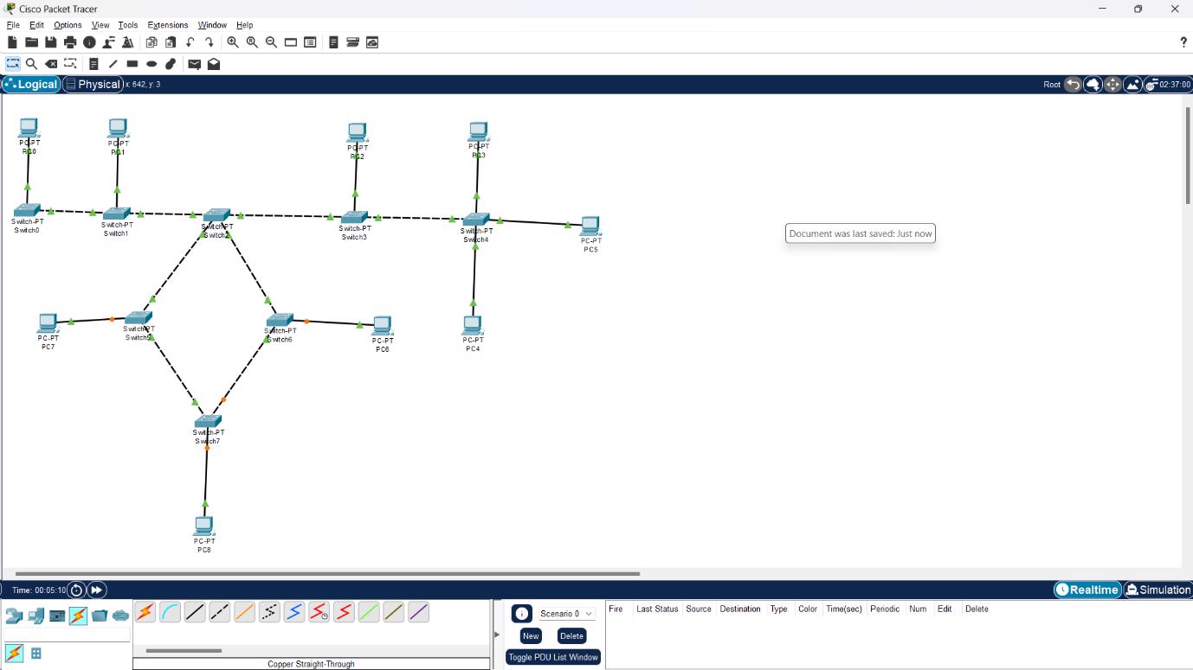

Step 2 : Assign IP address



Step 3 : verify connection using ping command

Step 4 : Send PDU packets one targeted from PC0 to PC3 and another targeted from PC1 to PC2.

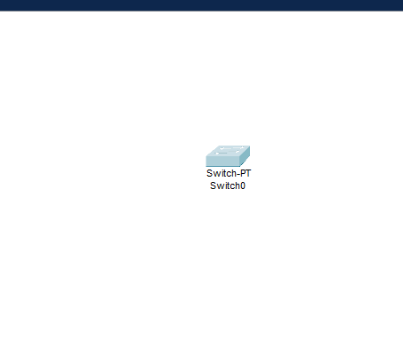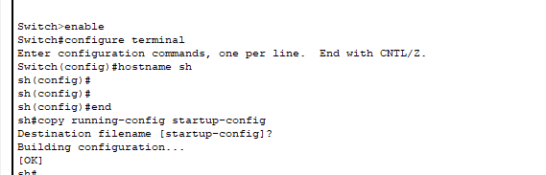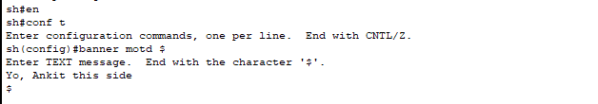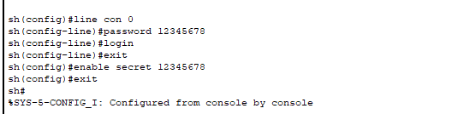

On every next login it will ask for password

1.Select Router 2911 and a Pc from End Devices

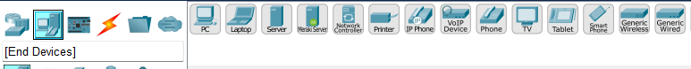

2.Then go to connection and select console connection

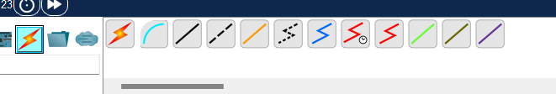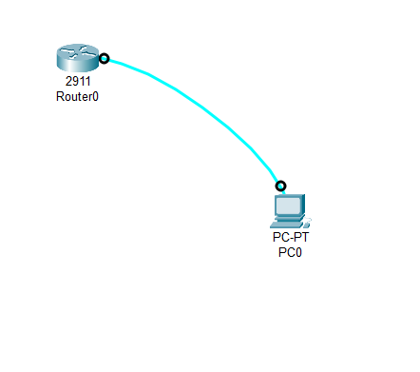

3. Open Terminal and Execute the Following commands

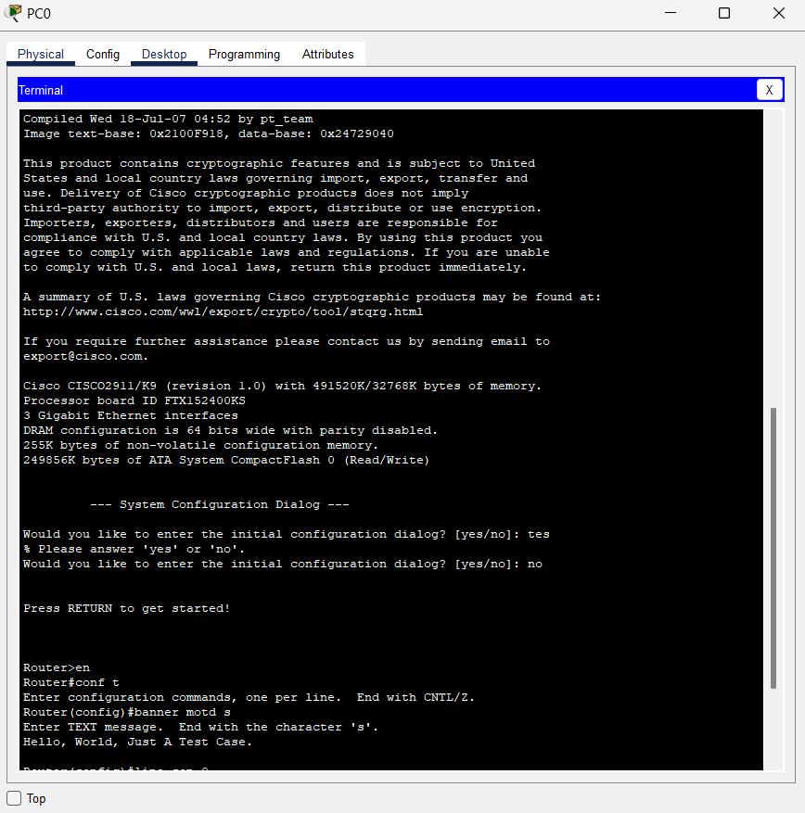

On every next login it will ask for password

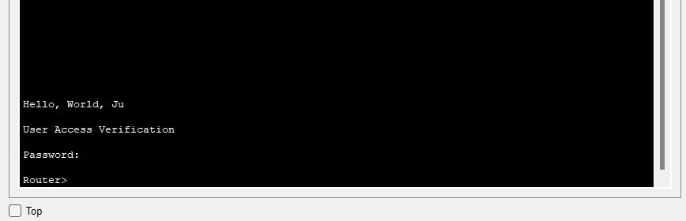

**Client server**

